 | Catshill Village Surgery  Wishing you all a lovely Easter holiday |  | March 2023
 |  | . | Regular Practice hours  Monday 8:00am – 6:30pm  Tuesday 8:00am – 6:30pm  Wednesday 8:00am – 6:30pm  Thursday 8:00am – 1 pm  Friday 8:00am – 6:30pm  The surgery is closed every lunch time between:  1:00pm and 2:00pm  We are also closed for the following Bank Holidays:  Friday 7th April  Monday 10th April  Monday 1st May  Monday 8th May  Monday 29th May  Reception phone lines are open at 8.00am  Online access is always available.  Telephone No: 01527 872 426 Email: catshill.surgery@nhs.net www.catshillvillagesurgery.co.uk
Enhanced Access

Catshill Village Surgery is part of a national effort to provide sufficient routine appointments at evenings and weekends to meet locally determined demand, alongside effective access to out-of-hours and urgent care services. Bromsgrove PCN Practices are working together to provide access to the right person, providing the right care, in the right place at the right time by providing a limited number of additional routine appointments on some evenings and Saturdays with a GP, Pharmacist, Nurse Practitioner. In the first instance patients should contact us to book into one of these slots.

Bromsgrove Primary Care network is made up of nine practices which are as follows:
Catshill Village Surgery
Churchfields Surgery
St John’s Surgery
Davenal House
New Road Bromsgrove
New Road Rubery
Cornhill Surgery
Barnt Green Surgery
The Glebeland Surgery

Family & Friends test. | What to do in an emergency.
The NHS Friends and Family Test is an important opportunity for you to provide feedback on the services that provide your care and treatment. Your feedback will help NHS England to improve services for everyone. You can complete this on our website or via a card from Reception.  On our website you can also click the "did I get great care" tab to submit your feedback | If you have a life-threatening emergency example sudden weakness, speech disturbance, chest pain, collapse, major bleeding then you need to dial 999. The ambulance service is the most appropriate service to deal with these problems. Our services are here to deal with non-life-threatening conditions and so are not set up to deal with emergencies. Contacting us rather than the emergency services could result in a delay in getting you the right care.  Thank you for your understanding and support.  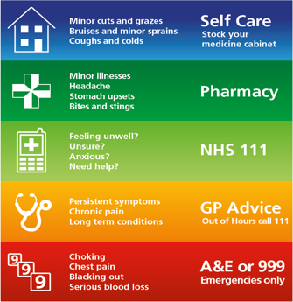

Cancel it. | Appointments.
When demand is high it can be difficult to get a routine appointment with a doctor or nurse. When patients fail to attend their appointments, this makes things harder.  When patients are declined routine appointments because they are all booked, it is very disappointing when one of those booked appointments does not turn up and has not contacted the surgery so it can be released for someone else.  The information below is gathered from 1st January – 27th March 2023  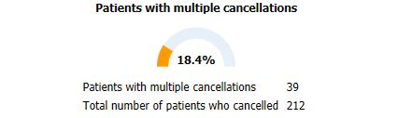  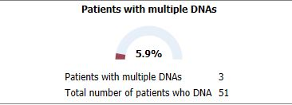 | 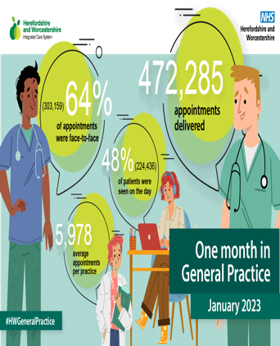

PPG meetings | COVID Boosters
The patient participation group is a group of people joining together in a voluntary capacity to enhance the Practice by working alongside the doctors and nurses on behalf of and representing the patients.  Our next meeting will be on the 7th of June at 16:00.  If you would like to become part of this group, please contact the surgery, and ask to speak to the Practice Manager. | Catshill village surgery are currently preparing to launch the COVID Booster programme. You may have heard about this in the news.  We aim to offer all our housebound patients the opportunity to get a COVID booster as a priority and then we will begin to offer this out to other eligible patients.  You will be contacted when the clinics have been arranged.  If you do not wish to have your COVID booster, please feel free to contact the practice and ask the team to enter a decline covid booster note to your medical records as this will stop any further SMS messages and calls inviting you to book an appointment.

