Catshill Village Surgery
Winter Newsletter 2021
Telephone No: 01527 872 426 Email: catshill.surgery@nhs.net www.catshillvillagesurgery.co.uk
Monday 8:00am – 6:30pm
Tuesday 8:00am – 6:30pm
Wednesday 8:00am – 6:30pm
Thursday 8:00am – 1 pm
Friday 8:00am – 6:30pm
Closed Saturday and Sunday

The surgery is closed every lunch time between:
1:00pm and 2:00pm
Reception phone lines are open at 8.00am
Online access is available at all times

Practice News
We are constantly reviewing our appointment system and do try to accommodate all of our patient’s needs. Please be aware that we are in a similar position to the NHS overall and are struggling to meet the current very high demand for appointments.GP appointments continue to be booked as a telephone consultation in the first instance. This has proved popular with many people and many things can be dealt with by telephone call only. If however, the GP feels that you need to be seen to manage your problem then this will be arranged in a face-to-face appointment at the surgery following your telephone consultation.

During the pandemic our GP appointment system was changed to a "book on the day" only system with no bookings in advance but from 29/11/21 we are offering a number of appointments that are bookable in advance. If your problem is not urgent for that day you might like to consider booking an appointment ahead.
Nursing department; with the exception of spirometry (testing for chronic lung disease) all nursing services are available and running at the surgery. If you have a long-term condition such as diabetes or asthma then you will be invited to the surgery for your annual review. We have previously done this during the month of your birth but please be aware that we are still catching up on reviews that have been delayed during the pandemic. Please bear with us - you will be called for and we will get your annual review done at the surgery.
Blood tests, ECGs, dressings, injections, immunisations and other routine services are running as normal."

Patients failing to attend appointments
Non attending patients and late arrivals for appointments are a concern. The numbers are now being highlighted in the waiting rooms and website. A new computer report showed that in the past month 6% of GP appointments were ‘DNA’. The doctors and staff at surgery aim to provide you with a high quality efficient confidential service that meets your needs. Our aim is to make your visits to us as friendly and effective as possible. We are continuously looking for ways to improve our services to you. In order to work together we need to ask that should you be unable to attend your appointment for any reason, please contact the surgery to cancel the booking. As times change and standards rise, we have constantly improved the facilities and services which we offer which we feel provides everything needed for the high quality of care and service which is now expected. While we have 'moved with the times' and have computerised our medical records, we pride ourselves in continuing to be a family practice where we have had families registered with us for generations.
When demand is high it can be difficult to get a routine appointment with a doctor or nurse. When patients fail to attend for their appointments this makes things harder.
When patients are declined routine appointments because they are all booked, it is very disappointing when one of those booked appointments does not turn up and has not contacted the surgery so it can be released for someone else. Remember – your DNA is another patient’s denied appointment and you might be the patient needing the appointment one day. Avoid becoming a DNA
Diabetes Clinics
Diabetes may be a progressive disease that can have long term health implications if not carefully managed. At Catshill Village Surgery patients with diabetes can expect a full annual diabetic review to monitor and manage the condition. You can expect a 30 minute appointment with the Practice Nurse and includes a weight check, blood pressure, foot screening, blood test and a discussion on lifestyle factors. Support may be offered to help enhance healthy living. A urine sample will also be required at this appointment.
For some people it may be necessary to make medication changes, therefore follow up appointments may be required throughout the year. This is necessary to monitor the response to blood glucose levels and ensure they are maintained within a safe range.
At CVS both Dr Ford and Nurse Jo McArthur specialise in Diabetes management. The annual reviews are also carried out by Nurse Helen Johnson.
Asthma Reviews
Asthma reviews have restarted at the surgery and are being completed in face to face appointments with our clinical pharmacist, Kathryn. Medication accounts for 25% of the carbon footprint of the NHS and inhalers are the biggest contributor to this. 5 doses of certain types of inhalers have large a carbon footprint similar to driving 8 miles in a car. Therefore the surgery is working to help ensure you are on the most effective inhaler for your needs whilst also looking to limit the impact on the environment. If you are on inhalers and would like to discuss this further please make an appointment with Kathryn and she will discuss this with you.
Patient Participation Group
We hold regular patient participation group meetings to keep patients up to date on any changes within surgery & to give you the opportunity of getting involved and having your say on the way we run. We are continually looking at ways to improve our services and value any comments and opinions our patients have. These meetings offer a chance for you to be involved in the life of the practice. It also provides us with the views of our patients regarding current and future developments of the surgery.
Our patient participation group have an increasingly important role to play in helping to give patients a say in the way services are delivered to best meet their needs, and the needs of the local community. Members can help GPs to develop an equal partnership with their patients. They can help them to communicate accurately and honestly with individual patients, and with the wider community about key health matters. They can also help to reduce costs and improve services by identifying changes that the practice may not have considered, allowing resources to be used more efficiently. What is more, they can develop mutually supportive networks for patients and the practice, outside of individual appointments.
If you would like to join the group, or have any ideas of topics and services you would like mentioned at these meetings please speak to reception.

PopmPoms4loneliness
Isolation is not just for Covid, for so many people we’re on a mission to change!
“Let’s spread the word about loneliness and isolation – take a pom-pom on a little vacation”
Like our page and post a photo to: www.facebook.com/pompoms4loneliness
Made to make a difference by The Coseley Community as part of the Just Start Talking Project by Just Straight Talk, Coseley.
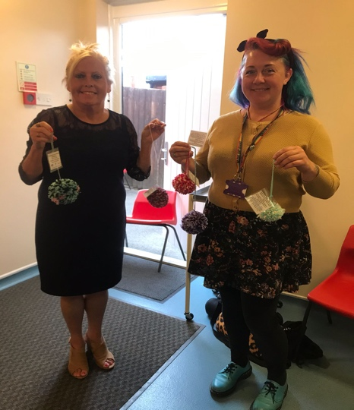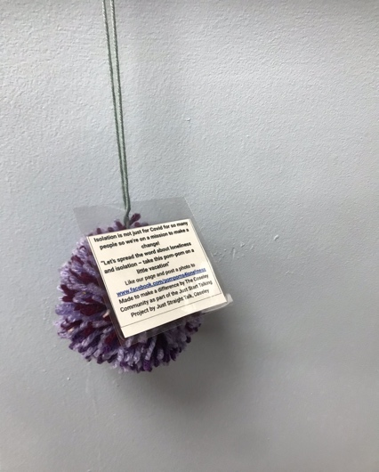
Community Pharmacy Consultation Service
We are starting a new approach to improve access for patients to GP appointments. The aim is to direct patients to the most appropriate healthcare professional, which may be a GP or a pharmacist.
If your symptoms could be resolved by a consultation with one of the local community pharmacists instead of the GP, we have asked our reception staff to give you a same-day referral to a local pharmacy of your choice. If the pharmacist advises that your symptoms do require an assessment by a GP they will contact us and we will ensure you are assessed by a GP.
We think this is a great service. Once you see how great your local pharmacist is – they are highly trained and skilled clinicians very experienced in treating minor illnesses – we don’t think you’ll look back. This will also help us to free up GP appointments for people with more complex health needs and ensure that everyone gets treated at the right time, by the right healthcare professional"

Christmas opening hours
It’s getting closer… Here are our Christmas opening times.
Friday 24th December | 08:00 - 18:30
Monday 27th December | Closed
Tuesday 28th December | Closed
Wednesday 29th December | 08:00 – 18:30
Thursday 30th December | 08:00 – 13:00
Friday 31st December | 08:00 – 18:30
Monday 3rd January | Closed
Tuesday 4th January | Normal surgery hours resume
From all of the team here at Catshill Village Surgery, we wish you all a lovely festive holiday.

