Catshill Village Surgery
Summer Newsletter 2021

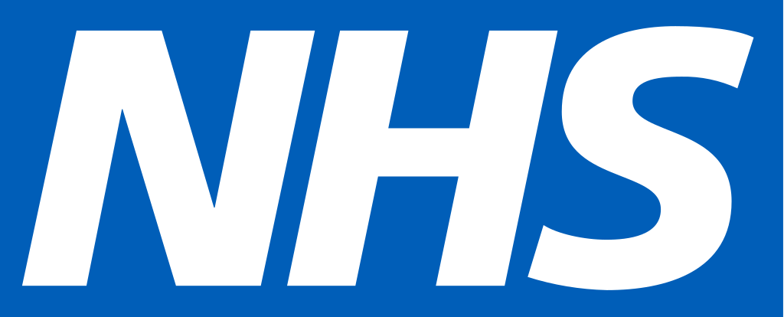
Telephone No: 01527 872 426 Email: catshill.surgery@nhs.net www.catshillvillagesurgery.co.uk
Monday 8:00am – 6:30pm
Tuesday 8:00am – 6:30pm
Wednesday 8:00am – 6:30pm
Thursday 8:00am – 1 pm
Friday 8:00am – 6:30pm
Closed Saturday and Sunday

The surgery is closed every lunch time between:
1:00pm and 2:00pm
Reception phone lines are open at 8.00am
Online access is available at all times

Welcome to our summer edition.
A lot has happened here at the surgery since our last newsletter was released. We would like to offer a warm welcome all of our new staff members.
Pauline Bloxham, Joanne Bourne & Megan Hayes have all joined the reception team as healthcare navigators. They will be on hand to answer your queries and help signpost you to the best healthcare professional depending on the nature of your query.
Ruth Ling has joined our clinical team as Healthcare Assistant & Phlebotomist. Ruth will offer our practice nurse, support and carry regular blood tests and annual reviews.
Susan Zaleska has joined the surgery as Practice & PCN – IT Care Coordinator and will offer clinical systems support to all staff amongst the nine surgeries within the Primary Care Network.
We would also like to mention that Kathryn Sacharewicz our long term Pharmacist has also taken on a shared role as Practice & PCN Pharmacist. Kathryn will continue her work here at the surgery however; take on additional work amongst the nine surgeries within the Primary Care Network.
We are delighted to welcome each new member to our growing surgery as together we continue offering all of our patients personable patient care.
COVID – 19 Vaccination update
Covid-19 vaccinations have continued to get underway and we have been inviting all of our eligible patients to book into our ongoing clinics. With all hands on deck we have managed to offer vaccinations to many of our patients without delay. The practice team have all worked hard, and together this has proven true community spirit. It has brought the practice team closer and with changes in work approach and the introduction of online access, telephone and video consultations we have all learnt that anything is possible. We do hope that during the COVID-19 pandemic and taking into account the restrictions that have been in place you have had a positive experience throughout. We have been informed that moving forward some of you may wish to have access to your COVID-19 vaccination certificate of passport as mentioned by the media. Please note this is available on the NHS app should you wish to download this. For patients that have Patient access to their online medical records your vaccination status will show there.
You can alternately contact 119 where a specific team are available to advise and offer you written confirmation.
PLEASE NOTE THE SURGERY IS UNABLE TO PROVIDE INDIVIDUAL WRITTEN VACCINATION STATUS.

Patient Participation Group
Many thanks, to all of our patients that have joined and taken part in our patient participation group. Even through these difficult times we have had a successful meeting and had an opportunity to listen to patient views. Patient feedback is and always will be extremely helpful and we look forward to future meetings as we all continue to make our approach a better approach offering a service provision developed as a community. If you would like to join our Patient Participation Group where you will be invited to come along to future meetings and offer us valuable insights please contact the surgery on 01527 872426. We want to hear from you!
NHS your NHS data matters
You may be aware that data held on your GP medical records is shared with other healthcare professionals for the purposes of your individual care. It is also shared with other organisation to support heath can care planning and research as you may have seen when using the NHS app or via NHS Digital. Did you know that you can opt out of this data sharing and request a dissent from secondary use of GP patient identifiable data? This is known as Type 1 Opt-out.
If you wish to Opt-out as per above, please take a look at what you need to do by going online using the following link:
https://www.nhs.uk/your-nhs-data-matters/manage-your-choice/
Alternatively you can let one of our receptionists know of your wish to opt out so that the relevant code can be added to your medical records.
Annual reviews
We have started to contact our patients eligible for their annual reviews. You may have noticed that we have started to contact our patients more often by text message in the first instance. This is a helpful tool not only to allow us to contact you for reviews but this has also proven successful as clinicians have been able to make contact with regards to results and many other areas. It has become apparent that patients also respond well to our text messages as this does not directly interfere with their day. This option can also allow for you the patient to send photos direct to the Clinician should you have a rash or other condition not always apparent on a telephone call.
If you have not already updated your medical records to include your mobile number, please consider doing this as we can keep you informed and up to date quickly. If you do not have a mobile number please do not worry, we will continue to contact you via post, it will just take a little longer for us to get hold of you.
Patient access/Online access
If you would like to have access to your medical records you can download the NHS App on your mobile phone or tablet. This is very easy to do and by following the simple steps you can have access to your medical records online. You can request and view your medication; you can access your allergies, immunisations, documents and test results.
Alternately you can contact the surgery where you will need to complete a form and produce photographic ID along with a recent utility bill as proof of your address. This can take up to 14 days and you will be contacted as soon as your account has been set up.

