 | Catshill Village Surgery |  | June 2022
We hope that you enjoy reading the latest news and updates at your local Practice, but we also hope that this newsletter will help you get to know your local Practice and the people who work here better.  Bethan Barrett aged 8 years has coloured in this picture to wish you all a wonderful Summer. |  |  | Don’t forget  Monday 8:00am – 6:30pm  Tuesday 8:00am – 6:30pm  Wednesday 8:00am – 6:30pm  Thursday 8:00am – 1 pm  Friday 8:00am – 6:30pm  The surgery is closed every lunch time between:  1:00pm and 2:00pm  Reception phone lines are open at 8.00am  Online access is available at all times  Telephone No: 01527 872 426 Email: catshill.surgery@nhs.net  www.catshillvillagesurgery.co.uk

Latest feedback left on our website from some of our patients
13th May 2022  Excellent treatment in the past from all doctors and nurses. This time, I had a problem with I.T., specifically concerning Patient Access. The office staff, particularly all the receptionists, whom I tended to pester in my somewhat agitated state, were extremely patient and understanding. (Special thanks to Ms. Zaleska for her cheerful, prompt and successful efforts on my behalf.)  21st April 2022  Extremely pleased with the level of care I have received at Catshill surgery. I never have a problem getting an appointment quickly (almost always the same day), which is the polar opposite of my experience with my previous surgery. Dr Bloxham and Dr Barratt are absolutely excellent- they listen carefully, are very kind, very sympathetic and extremely helpful and knowledge. I haven't yet had appointments with any of the other doctors yet, but I'm sure they're excellent too. Thank you so much, Catshill surgery! | 27th April 2022  Being a healthcare professional myself I have worked in many GP practices and have had experiences good and not so good as a patient. However, I have never experienced such a high standard throughout my whole time with Catshill village surgery.  The reception staff are respectful, caring extremely efficient and make you feel as though your request whatever it may be is important. When you call, they always try and do their best to help. I cannot commend them enough. Well Done. My son and his family, my daughter and her partner have had exactly the same experience. The GPs at the surgery are excellent. Most of my contact has been with Dr Barrett who I have found to be, compassionate, an excellent communicator, patient, and kind. This surgery should be identified as the Gold Standard for all to follow. |  | Did you know?  You can send us your feedback direct by using our website? There is a tab titled: Did you get great care?  By submitting your feedback, you can help improve our service
Community Pharmacy Consultation Service |  | What is a Care Navigator?
The NHS Community Pharmacist Consultation Service (CPCS) was launched by NHS England to facilitate patients having a same day appointment with their community pharmacist for minor illness, improving access to services and providing more convenient treatment closer to patients’ homes or workplaces.  The service is helping to alleviate pressure on GP appointments and emergency departments, in addition to harnessing the skills and medicines knowledge of pharmacists.  The practice reception care navigator, practice nurse or GP, makes a digital referral to a convenient pharmacy, where the patient will receive pharmacist advice and treatment for a range of minor illnesses.  Should the patient need to be escalated or referred to an alternative service, the pharmacist can arrange this.  For more information, please visit our website where Kathryn, our pharmacist, has provided more detail about this service and what it means for our patients.  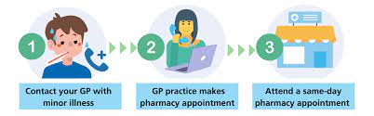 |  | A Care Navigator is someone who works in the reception area of your local GP Practice, whose job it is to support you in getting the help you need. Care Navigators undergo training and, as part of their role, have access to a directory of services to help get you to the right place, at the right time.  To enable them to do this, they will ask you some questions about your condition. They will help you to play an active role in managing your own health. When directing you to the most appropriate service for your needs, they may also help you with things like booking an appointment.  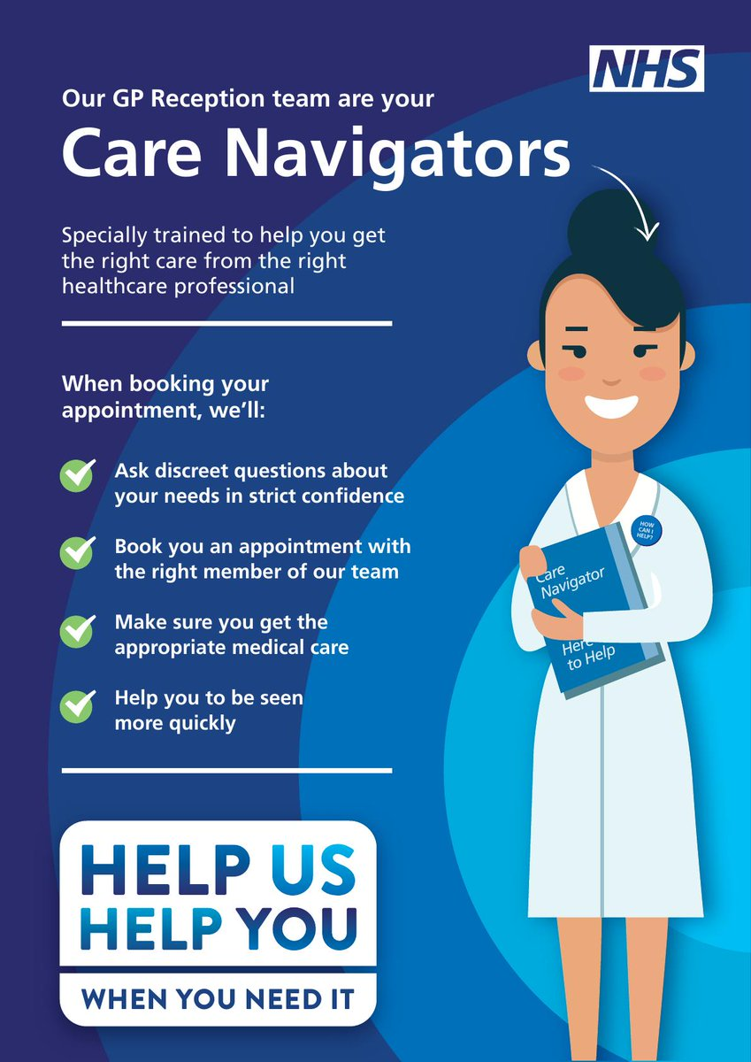

Travel clinics
Cervical Screening Awareness week

If you are planning to travel abroad this year, you may need to be vaccinated against serious infectious diseases found overseas. These may be vaccines that are not included in the UK routine vaccination programme.  Catshill Village Surgery can provide free NHS vaccinations and travel health advice, which is specific to the country you are visiting. This includes  - Diptheria, Tetanus and Polio  - Hepatitis A  - Typhoid  - Cholera  A pre travel risk assessment form must be filled in and returned at least 8 weeks before departure. Some vaccines need to be given well in advance to allow your body to develop immunity. This can be obtained from the surgery website. The practice nurse, Jo or Helen, will refer to the national guidelines and check the patient’s vaccination records. They will identify if any vaccines are required and if there are other risks to health, considering medical history and medication. If vaccines are required that cannot be given on the NHS, such as Yellow Fever, Japanese Encephalitis or Rabies, then it may be necessary for you to source these vaccines privately.  Some countries require certification for proof of vaccine, such Yellow Fever and Polio. It is important that you consider this before travel and allow sufficient time for arrangements to be made.  You can find out more information at https://travelhealthpro.org.uk/  Happy Holidays!! |  | Cervical screening is a free health test available on the NHS as part of the national cervical screening programme. It helps prevent cervical cancer by checking for a virus called high-risk HPV and cervical cell changes. It is not a test for cancer. It is your choice whether to go for cervical screening.  - Cervical screening aims to identify whether you are at higher risk of developing cervical cell changes or cervical cancer. This means you can get any care or treatment you need early.  In the UK, you are automatically invited for cervical screening if you are: between the ages of 25 to 64 registered as female with a GP surgery.  We are here to help  As a GP practice we are here to help meet the medical needs of our patients. We update our website and Facebook page frequently. We have a dedicated team of clinical and admin staff working hard behind the scenes every day to ensure we offer you the best care possible.  We do however find ourselves dealing with issues that are beyond our control Hospitals and other external providers are experiencing severe backlogs. We are unable to do anything about this unfortunately. We only make the referral and have no control from that point as to the length of waiting time or level of priority.  If you are experiencing a delay from another provider that is not your GP we advise that you contact the provider and not the surgery please.

GP Appointments
When you call us, it is particularly important that you give the receptionists the information about the reason for you requesting an appointment so that your call can be dealt with in the most efficient way.  Cancel it  When demand is high it can be difficult to get a routine appointment with a doctor or nurse. When patients fail to attend for their appointments this makes things harder.  When patients are declined routine appointments because they are all booked, it is very disappointing when one of those booked appointments does not turn up and has not contacted the surgery so it can be released for someone else. |  |  | We wanted to share a little insight into our appointment data from:  31st March 2022- 31st May 2022  Thank you to those who attended or contacted us to cancel an appointment.  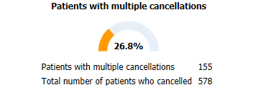  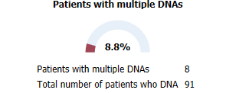  Remember – your DNA is another patient’s denied appointment, and you might be the patient needing the appointment one day.

Patients from Ukraine
How to Access the NHS in Worcestershire guide in both English and Ukrainian.  With many households in Worcestershire supporting families as part of the Homes for Ukraine programme, we’ve created resources to help both new arrivals and the families hosting them to make the most of the NHS services available in our local area.  We’ve also created translated versions of the GP registration forms, which all new arrivals will need to complete in order to register with a GP.  These include the GMS1 form, required to register at any GP practice in England, and a generic New Patient Questionnaire, which should answer most of the questions your practice will need to ask as part of their initial patient screening when you join.  The translated guides and all forms can be found on our website. | We hope this information is helpful to both those newly arriving in our wonderful county, and to those generous enough to open- up their homes. |  | Cervical Screening Awareness week  20-26 the June  For more information please visit:  https://www.jostrust.org.uk/get-involved/campaign/cervical-screening-awareness-week
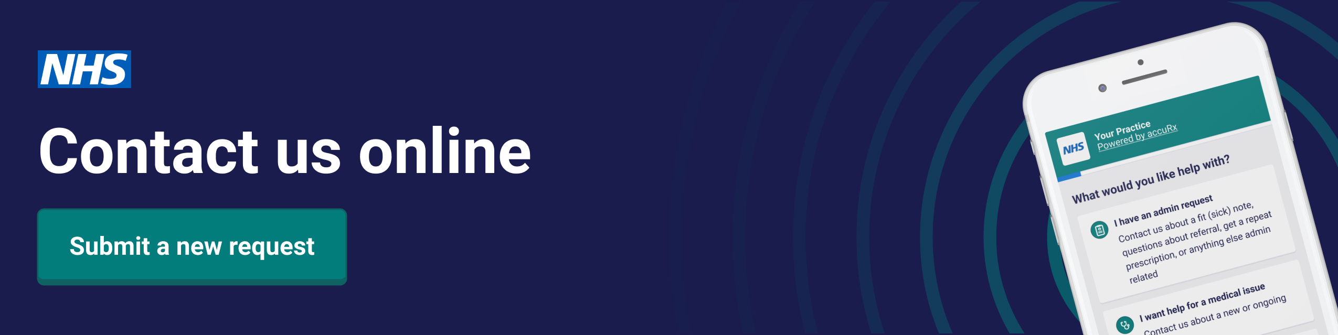
We have now gone live with our new online consultation service-Patient Triage. This is a great way for you to contact our practice for admin requests. It is very simple to fill out so please do give it a go if you need to contact us.
We have temporarily paused online medical enquiries so that we can become familiar with this new system safely. You can however continue to use this service for all non-medical enquires by selecting - (I have an admin query).
The (I have an admin query) option will allow you to contact the practice about:
• Recent tests
• Order a repeat prescription
• Request a sick note
• Ask a question about a referral
• Request a doctor’s letter

Although the character count is limited on the form, please try to give as much specific and concise information as possible. We really think it is easier for most people than waiting on hold to speak to a receptionist but would love to hear your feedback.
If you do not have access to the internet or find it difficult to use a computer or smartphone you can call reception instead. You can access the new service via our website.

