PPG

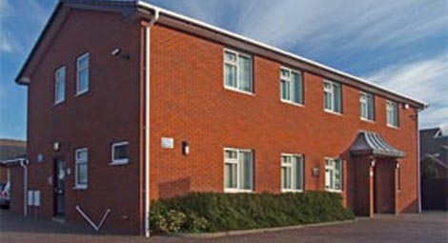
Would you like to have a say about the services at Catshill Village Surgery?

By becoming a part of our Patient Participation Group (PPG) you can make a difference by communicating with surgery staff to make improvements and encouraging patients to participate in health promotion.

You can join our face to face group which involves a quarterly meeting with practice staff.
Or join the virtual group, this means providing your email details so that we can contact you occasionally to ask you for your views.

Want to join?
Fill in your details on the inside of this leaflet.

Catshill Village Surgery
CATSHILL VILLAGE SURGERY PPG
If you are interested in becoming a member of our Patient Participation Group (PPG) please complete this form and hand it in at reception, or post it into the secure prescription request box.

I am interested to join: (please tick)

The face to face group The virtual group

Name:

Email address:

Postcode:

The additional information will ensure we try to speak to a representative sample of the patients that are registered at this practice.

Gender: Male Female Prefer not to say

Age group:
Under 16 |  | 17 – 24
25 – 34 |  | 35 – 44
45 – 54 |  | 55 – 64
65 – 74 |  | 75 – 84
Over 84

Ethnic Origin:

White
British |  | Irish

Mixed
White & Black Caribbean |  | White & Black African |  | White & Asian
Asian or Asian British
Indian |  | Pakistani |  | Bangladeshi
Black or Black British
Caribbean |  | African
Chinese or other Ethnic Group
Chinese |  | Any Other

How often do you come to the practice?

Regularly Occasionally Very rarely

Thank you for your interest in joining our PPG. A member of practice staff will be in touch with you shortly.

